Functional Specification Document (FSD)
Order-to-Cash (O2C) & Inventory Automation System | Client (fictional): PT Maju Distribusi Nusantara | Prepared by: Alief Sukma Dewanta, Business Analyst / System Analyst | Version 1.0 | November 2026
Portfolio note: the client is fictional and all figures are simulated. This FSD specifies how the system behaves to meet the business requirements (BRQ) in the companion Business Requirements Document (BRD). Requirement IDs (FR, BR, NFR) are the same IDs used in the traceability matrix and test workbook.

1. Document Control
Item | Detail
Document | Functional Specification Document
Companion document | Business Requirements Document (BRD)
Status | Draft for review
Target platform | Odoo ERP (Sales, Inventory, Purchase, Invoicing) plus configured rules
Related files | Requirements workbook, test management workbook (RTM, test cases, UAT), wireframes

Version | Date | Author | Change
0.1 | Nov 2026 | A. S. Dewanta | Combined BRD/FSD draft
1.0 | Nov 2026 | A. S. Dewanta | Split into FSD; roles, screens, validation, and diagrams added

2. Purpose and Scope
This document defines the functional behaviour, business rules enforcement, data model, screens, notifications, and non-functional requirements of the O2C system. It covers 46 functional requirements in seven modules and 7 non-functional requirements. Scope boundaries (in and out of scope) are defined in the BRD, section 5. Payment gateway integration, transport routing, and multi-warehouse support are out of scope.

3. Solution Overview
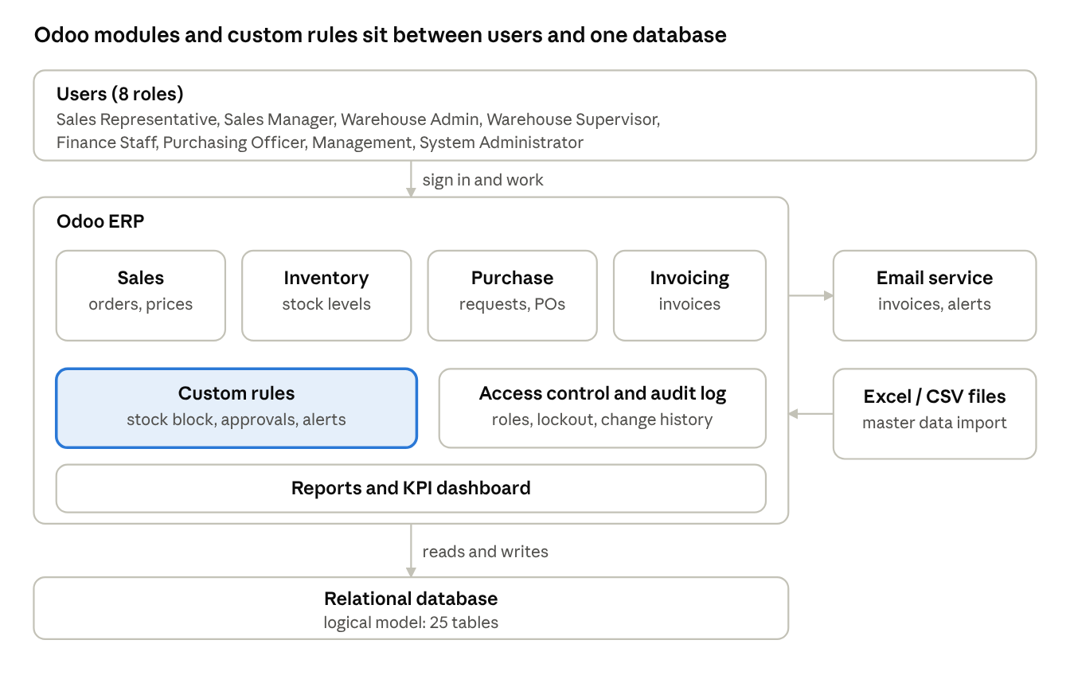
solution architecture · users, Odoo modules, custom rules, database
Component | Responsibility
Sales | Customers, price lists, quotations and orders, approvals
Inventory | On hand, reserved and available quantities, reservations, delivery orders, backorders, adjustments, counts
Purchase | Reordering rules, purchase requests, purchase orders, goods receipts
Invoicing | Invoices from delivered quantities, payment terms, payments, credit notes, receivables aging
Custom rules | Overselling block, approval routing, notifications that standard configuration does not provide
Access control and audit | Roles, permissions, account lockout, record of changes
Reports and dashboard | Stock report, sales report, KPI dashboard, Excel and CSV export
The platform fit for each requirement area (Fit, Config, Custom) is recorded in the Odoo fit-gap analysis and must be verified in the installed version.

4. Users and Roles
Role | Description
Sales Representative | Creates and confirms orders for assigned customers
Sales Manager | Approves large orders, high discounts, and credit exceptions; sees all orders
Warehouse Admin | Picks, ships, records returns and goods receipts, requests stock adjustments
Warehouse Supervisor | Approves stock adjustments and over-receipts; manages cycle counts
Finance Staff | Manages invoices, payments, and credit notes
Purchasing Officer | Handles purchase requests and supplier orders
Management | Read-only access to reports and the KPI dashboard (Operations Director)
System Administrator | Manages users, roles, and configuration

4.1 Permission Matrix
Function | Sales Rep | Sales Mgr | WH Admin | WH Supervisor | Finance Staff | Purchasing | Management | System Admin
Create and edit draft order | Own customers | All | - | - | - | - | - | -
Confirm order | Own customers | All | - | - | - | - | - | -
Approve order | - | Yes | - | - | - | - | - | -
Cancel order before shipment | Own | All | - | - | - | - | - | -
View stock levels | View | View | View | Full | View | View | View | -
Request stock adjustment | - | - | Yes | Yes | - | - | - | -
Approve stock adjustment | - | - | - | Yes | - | - | - | -
Pick and ship | - | - | Yes | Yes | - | - | - | -
Record return | - | - | Yes | Yes | View | - | - | -
Goods receipt | - | - | Yes | Yes | - | View | - | -
View invoices | Own orders | View | - | - | Yes | - | View | -
Record payment and credit note | - | - | - | - | Yes | - | - | -
Purchase requests and orders | - | - | - | View | - | Yes | View | -
KPI dashboard | Own | Yes | - | Yes | Yes | - | Yes | -
View audit log | - | View | - | - | - | - | View | Yes
Manage users and roles | - | - | - | - | - | - | - | Yes

5. Use Cases
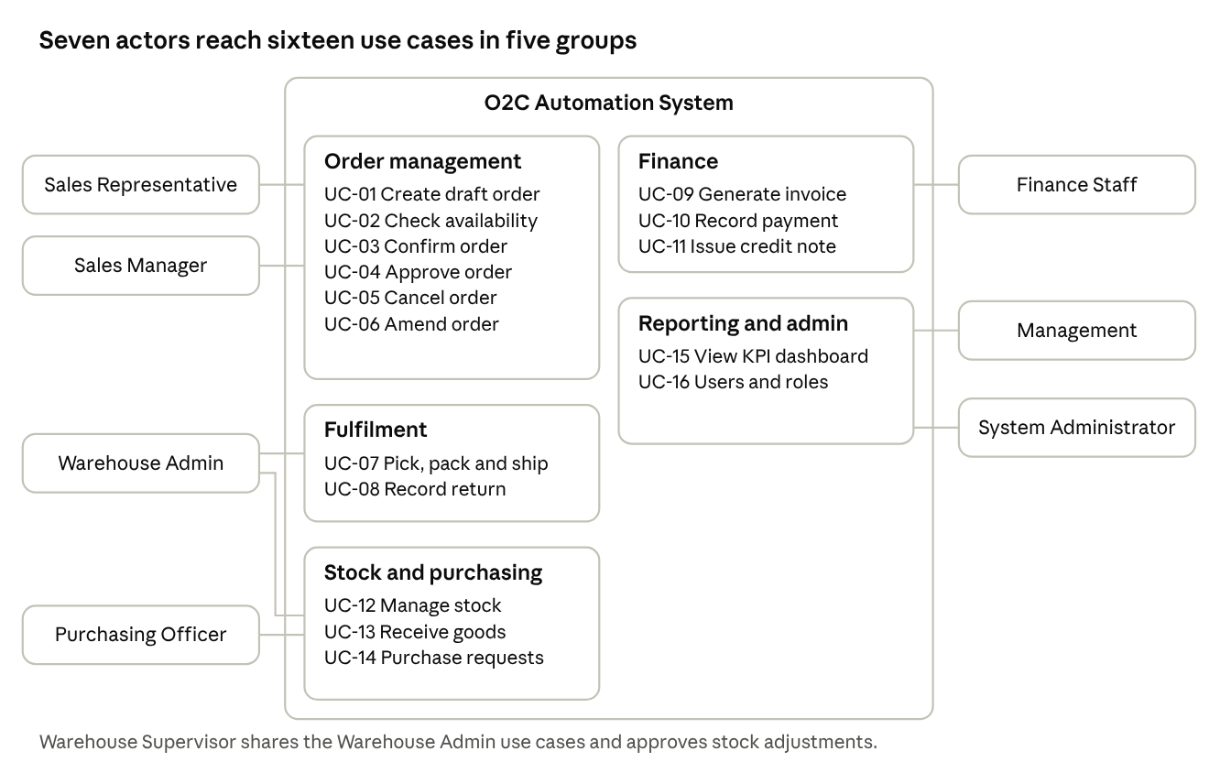
use case overview · 7 actors, 16 use cases in 5 groups
ID | Use case | Primary actor | Trigger | Requirements
UC-01 | Create draft order | Sales Representative | Customer order received | FR-ORD-01, FR-ORD-04, FR-MD-01, FR-MD-02
UC-02 | Check availability | Sales Representative | Adding a product line | FR-ORD-02, FR-INV-01
UC-03 | Confirm order | Sales Representative | Order ready | FR-ORD-03, FR-ORD-07, FR-INV-02
UC-04 | Approve order | Sales Manager | Order in Pending Approval | FR-ORD-05, FR-ORD-06
UC-05 | Cancel order | Sales Representative | Customer cancels | FR-ORD-08, FR-INV-03
UC-06 | Amend confirmed order | Sales Representative | Customer changes quantity | FR-ORD-09
UC-07 | Pick, pack, and ship | Warehouse Admin | Order confirmed | FR-SHP-01 to FR-SHP-05, FR-INV-04
UC-08 | Record return | Warehouse Admin | Goods returned | FR-SHP-06
UC-09 | Generate invoice | System | Shipment marked Shipped | FR-FIN-01 to FR-FIN-03
UC-10 | Record payment | Finance Staff | Payment received | FR-FIN-04, FR-FIN-07
UC-11 | Issue credit note | Finance Staff | Approved return or correction | FR-FIN-05, FR-FIN-06
UC-12 | Manage stock | Warehouse Admin, Supervisor | Variance found, count scheduled | FR-INV-05, FR-INV-08, FR-INV-09
UC-13 | Receive goods | Warehouse Admin | Supplier delivery | FR-INV-07
UC-14 | Manage purchase requests | Purchasing Officer | Low-stock alert | FR-INV-06
UC-15 | View KPI dashboard | Management | Periodic review | FR-RPT-01 to FR-RPT-04
UC-16 | Manage users and roles | System Administrator | Staff change | FR-SEC-01 to FR-SEC-04

6. Functional Requirements
Priority uses MoSCoW: M = Must, S = Should, C = Could. Summary: 46 requirements (31 Must, 13 Should, 2 Could).

6.1 Master Data (MD)
ID | Requirement | Priority
FR-MD-01 | The system shall allow creating and editing customer records with name, address, contact, payment terms, credit limit, and assigned sales rep. | M
FR-MD-02 | The system shall allow creating and editing product records with SKU, name, unit of measure, price, and reorder point. | M
FR-MD-03 | The system shall support customer-specific price lists that override the default product price. | S
FR-MD-04 | The system shall prevent duplicate SKUs and duplicate customer tax IDs. | M
FR-MD-05 | The system shall support bulk import of customers and products from CSV or Excel with row-level error reporting. | S

6.2 Sales and Order Management (ORD)
ID | Requirement | Priority
FR-ORD-01 | The system shall allow a Sales Rep to create a draft order for a customer with one or more product lines. | M
FR-ORD-02 | The system shall display real-time available stock (on hand minus reserved) for each product while the order is being entered. | M
FR-ORD-03 | The system shall block order confirmation when any line quantity exceeds available stock and show the available quantity (BR-01). | M
FR-ORD-04 | The system shall calculate line totals, discounts, tax, and order total automatically. | M
FR-ORD-05 | The system shall route orders above IDR 50,000,000 or discounts above 10% to the Sales Manager for approval (BR-04, BR-09). | M
FR-ORD-06 | The system shall check the customer's credit limit and overdue balance at confirmation and block or route for approval (BR-03). | S
FR-ORD-07 | The system shall move orders through the statuses Draft, Pending Approval, Confirmed, Processing, Partially Shipped, Shipped, Completed, and Cancelled. | M
FR-ORD-08 | The system shall allow cancelling an order before shipment and release its reserved stock (BR-06). | M
FR-ORD-09 | The system shall allow editing a confirmed order only through an amendment that re-validates stock and is logged. | S
FR-ORD-10 | The system shall send an order confirmation email or document to the customer. | C

6.3 Inventory Management (INV)
ID | Requirement | Priority
FR-INV-01 | The system shall maintain On Hand, Reserved, and Available quantities per product, where Available = On Hand minus Reserved. | M
FR-INV-02 | The system shall reserve stock automatically when an order is confirmed (BR-02). | M
FR-INV-03 | The system shall release reserved stock when an order is cancelled or an amendment reduces quantity. | M
FR-INV-04 | The system shall reduce On Hand quantity when a shipment is confirmed. | M
FR-INV-05 | The system shall support manual stock adjustments with a mandatory reason code and Supervisor approval. | M
FR-INV-06 | The system shall generate a low-stock alert and draft purchase request when Available falls below the reorder point (BR-07). | M
FR-INV-07 | The system shall support goods receipt against a purchase order and increase On Hand accordingly. | M
FR-INV-08 | The system shall support cycle count sessions and show variance between system and counted quantity. | S
FR-INV-09 | The system shall show a stock movement history per product. | S

6.4 Warehouse Fulfilment and Shipping (SHP)
ID | Requirement | Priority
FR-SHP-01 | The system shall notify the Warehouse team and create a pick list when an order is confirmed. | M
FR-SHP-02 | The system shall allow the Warehouse Admin to record picked quantities per line. | M
FR-SHP-03 | The system shall allow partial shipment when picked quantity is less than ordered, keeping the remainder as a backorder. | S
FR-SHP-04 | The system shall generate a delivery note for each shipment. | M
FR-SHP-05 | The system shall allow marking a shipment as Shipped and later as Delivered with a timestamp and receiver name. | M
FR-SHP-06 | The system shall support recording a customer return with reason and restocking decision. | S

6.5 Finance and Invoicing (FIN)
ID | Requirement | Priority
FR-FIN-01 | The system shall automatically generate an invoice when a shipment is marked Shipped (BR-05). | M
FR-FIN-02 | The system shall produce a PDF invoice and email it to the customer's billing contact. | M
FR-FIN-03 | The system shall set the invoice due date from the customer's payment terms. | M
FR-FIN-04 | The system shall allow recording full or partial payments against an invoice and update payment status (Unpaid, Partially Paid, Paid, Overdue). | M
FR-FIN-05 | The system shall lock a sent invoice and allow corrections only via credit note (BR-10). | M
FR-FIN-06 | The system shall create a credit note linked to a return or an invoice correction. | S
FR-FIN-07 | The system shall show an accounts receivable aging report (current, 1-7, 8-30, over 30 days). | S
FR-FIN-08 | The system shall send an automatic payment reminder for invoices past due. | C

6.6 Reporting and Dashboard (RPT)
ID | Requirement | Priority
FR-RPT-01 | The system shall provide a dashboard showing order processing time, order volume by status, and overselling blocks. | S
FR-RPT-02 | The system shall provide a stock level report with low-stock and stockout indicators. | M
FR-RPT-03 | The system shall provide a sales report by customer, product, and sales rep for a selected period. | S
FR-RPT-04 | The system shall allow exporting reports to Excel or CSV. | S

6.7 Security and Audit (SEC)
ID | Requirement | Priority
FR-SEC-01 | The system shall enforce role-based access control as defined in section 4. | M
FR-SEC-02 | The system shall record an audit log of status changes, price overrides, approvals, and stock adjustments with user and timestamp (BR-08). | M
FR-SEC-03 | The system shall require authentication and lock an account after 5 failed login attempts. | M
FR-SEC-04 | The system shall allow the System Administrator to create, disable, and reassign users and roles. | M

7. Business Rules and Where the System Enforces Them
Rule | Statement | Enforced at | Related FR
BR-01 | Order cannot be confirmed if quantity exceeds available stock | Order confirmation, atomic stock update | FR-ORD-03
BR-02 | Confirmation reserves stock; reserved stock is not available to others | Order confirmation | FR-INV-02
BR-03 | Credit limit and overdue balance control for credit orders | Order confirmation (customer check) | FR-ORD-06
BR-04 | Orders above IDR 50,000,000 need Sales Manager approval | Order confirmation (total check) | FR-ORD-05
BR-05 | Invoice created only when goods (or part) are shipped | Shipment confirmation | FR-FIN-01
BR-06 | Cancel releases stock; no cancellation after shipment | Cancel action, status check | FR-ORD-08, FR-INV-03
BR-07 | Low available stock creates alert and draft purchase request | After every stock change | FR-INV-06
BR-08 | Critical changes are logged with user and time | All status, price, approval, adjustment actions | FR-SEC-02
BR-09 | Discounts above 10% need Sales Manager approval | Order confirmation (discount check) | FR-ORD-05
BR-10 | Sent invoices are locked; corrections use credit notes | Invoice edit action | FR-FIN-05

8. Order Status Model
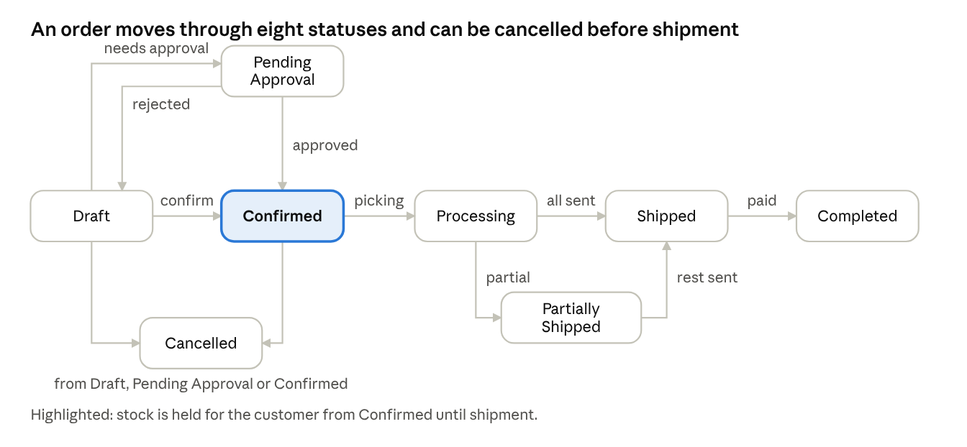
order status diagram · 8 statuses, 11 transitions
From | To | Trigger | Rule
Draft | Pending Approval | Confirm with approval condition met | BR-03, BR-04, BR-09
Draft | Confirmed | Confirm, stock sufficient | BR-01, BR-02
Pending Approval | Confirmed | Manager approves | Stock re-validated
Pending Approval | Draft | Manager rejects | Reason required
Confirmed | Processing | Warehouse starts picking
Processing | Partially Shipped | Partial shipment confirmed | FR-SHP-03
Processing or Partially Shipped | Shipped | Full shipment confirmed | Invoice generated, BR-05
Shipped | Completed | Delivery confirmed and invoice fully paid
Draft, Pending Approval, or Confirmed | Cancelled | Cancel before shipment | BR-06

9. Process Logic

9.1 Confirming an Order and Reserving Stock
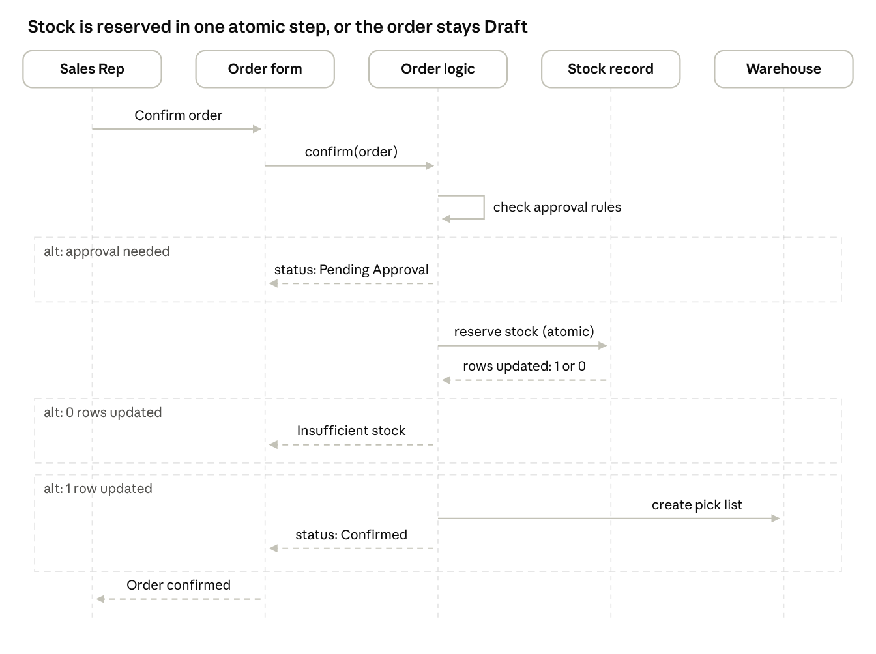
sequence diagram · confirm order and reserve stock
- The Sales Rep confirms the order. The system checks the approval rules (credit limit, order total, discount).
- If an approval is needed, the status becomes Pending Approval and no stock is reserved.
- Otherwise the system reserves stock with one atomic update that succeeds only if available stock covers the quantity and the stock record has not changed since it was read.
- If no row is updated, the order stays Draft and the user sees "Insufficient stock. Available: X". This is also how simultaneous orders for the last units are handled (NFR-02): one succeeds and the other is rejected.
- On success the order becomes Confirmed, a pick list is created for the warehouse, and the change is written to the audit log.

9.2 Shipping and Invoicing
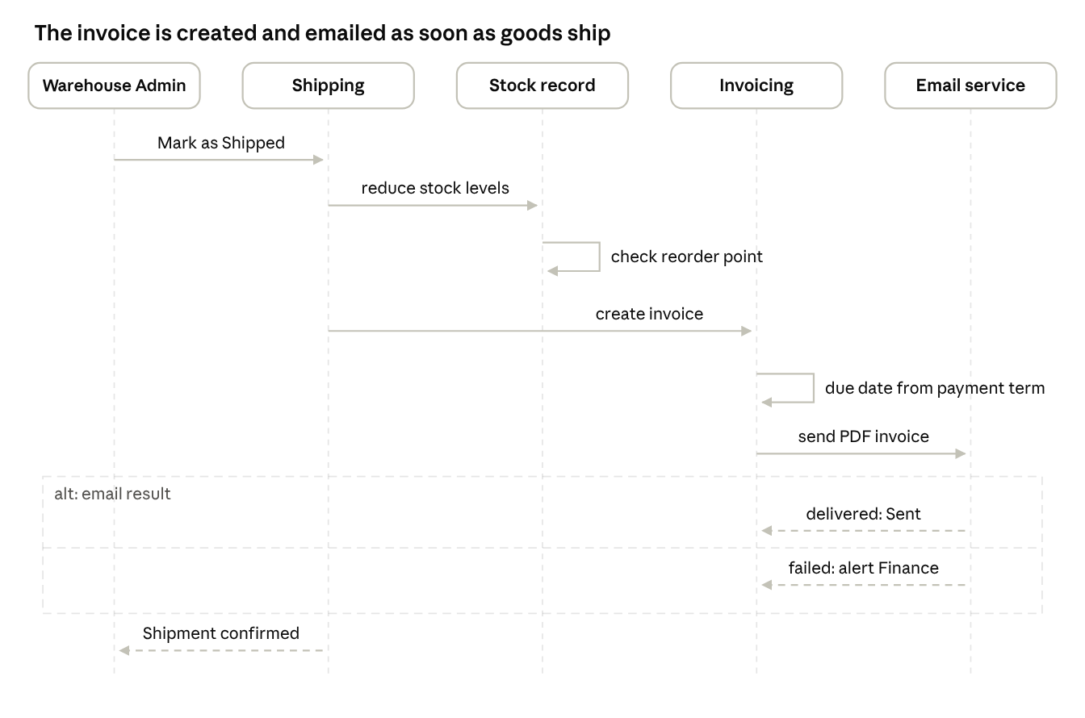
sequence diagram · ship, invoice, and email
- The Warehouse Admin marks the shipment as Shipped (full or partial).
- The system reduces On Hand and Reserved by the shipped quantity and checks the reorder point.
- The system creates an invoice for the shipped lines only, sets the due date from the payment term, and emails the PDF.
- If the email fails, the invoice is saved with status Failed and Finance is alerted.

10. Data Model
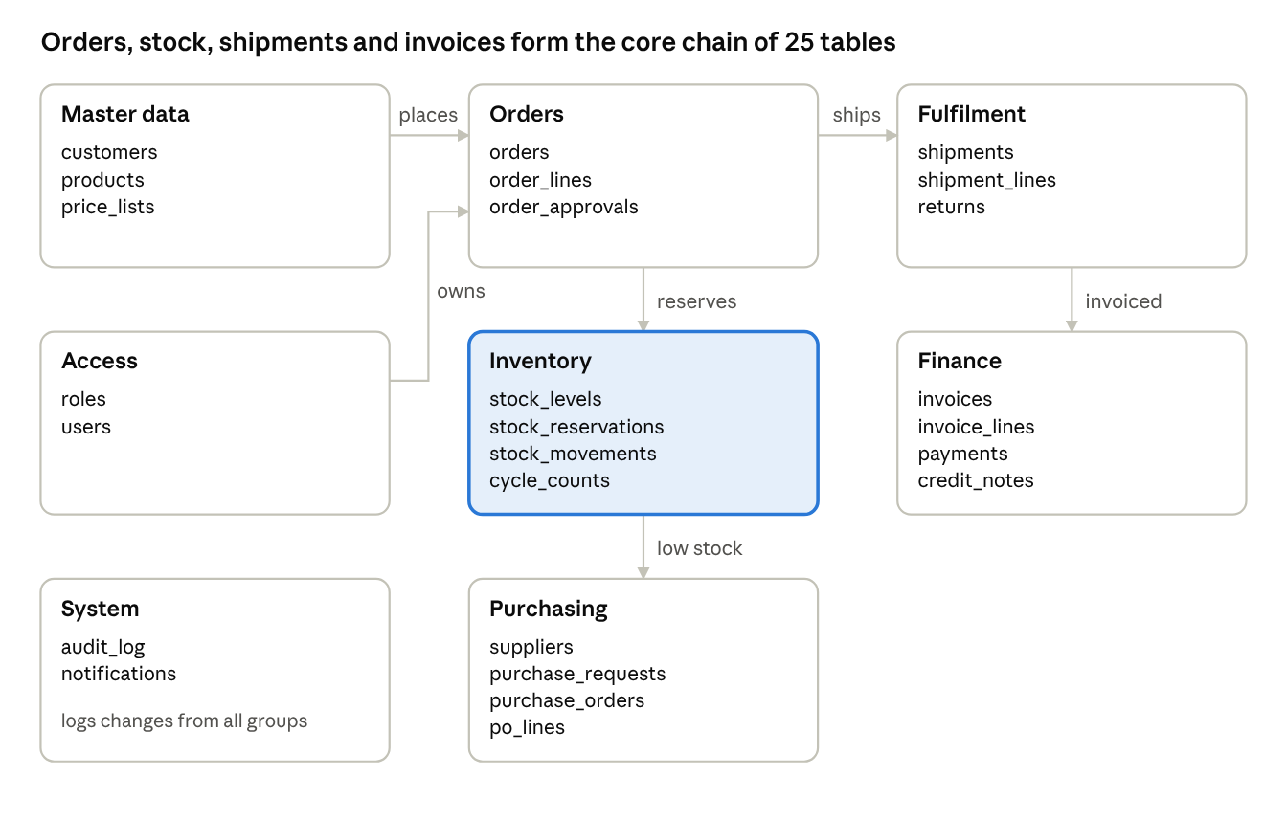
data model overview · 25 tables in 8 groups
The logical model has 25 tables. Available stock is derived (On Hand minus Reserved) and never stored. The full column list, keys, and constraints are in the ERD documentation and DBML file.
Group | Tables
Access | roles, users
Master data | customers, products, price_lists
Orders | orders, order_lines, order_approvals
Inventory | stock_levels, stock_reservations, stock_movements, cycle_counts
Fulfilment | shipments, shipment_lines, returns
Finance | invoices, invoice_lines, payments, credit_notes
Purchasing | suppliers, purchase_requests, purchase_orders, po_lines
System | audit_log, notifications
Key design decisions
- On Hand and Reserved quantities are stored separately; Available is calculated.
- Reservations are kept per order line so cancellations and partial shipments release or consume exactly the right units.
- Stock records carry a version number so that concurrent confirmations cannot both reserve the last units.
- Invoices link to shipments, so partial shipments produce partial invoices.
- Sent invoices are locked; corrections use credit notes.
- The audit log is insert-only.

11. Screens and Navigation
Wireframes for five of these screens are available as an editable canvas (order entry, stock levels, pick list and shipment, invoices, KPI dashboard).
ID | Screen | Main fields and actions | Roles | Requirements
SCR-01 | Login | Email, password; lockout message | All | FR-SEC-03
SCR-02 | Customers | List, create, edit, import CSV | Sales Mgr, Admin | FR-MD-01, FR-MD-04, FR-MD-05
SCR-03 | Products and price lists | List, create, edit, price list | Sales Mgr, Admin | FR-MD-02, FR-MD-03
SCR-04 | Sales order (wireframe 1) | Customer, lines, available stock, totals, Save draft, Confirm | Sales Rep, Sales Mgr | FR-ORD-01 to FR-ORD-04, FR-ORD-08
SCR-05 | Approval queue | Orders pending approval, approve, reject with reason | Sales Mgr | FR-ORD-05, FR-ORD-06
SCR-06 | Stock levels (wireframe 2) | On Hand, Reserved, Available, reorder point, status; adjustment, count, history | Warehouse, Purchasing | FR-INV-01, FR-INV-05, FR-INV-08, FR-INV-09, FR-RPT-02
SCR-07 | Pick list and shipment (wireframe 3) | Ordered, picked, backorder; delivery note; Mark shipped | Warehouse | FR-SHP-01 to FR-SHP-05
SCR-08 | Returns | Return lines, reason, restock choice | Warehouse | FR-SHP-06
SCR-09 | Invoices and payments (wireframe 4) | Aging tiles, status, email status, record payment, credit note | Finance | FR-FIN-01 to FR-FIN-07
SCR-10 | Purchase requests and orders | Draft requests, convert to PO, goods receipt | Purchasing, Warehouse | FR-INV-06, FR-INV-07
SCR-11 | KPI dashboard (wireframe 5) | KPI tiles, charts, date and sales rep filters, export | Management, managers | FR-RPT-01, FR-RPT-03, FR-RPT-04
SCR-12 | Users and roles | Create, disable, assign roles; audit log view | Admin | FR-SEC-01, FR-SEC-02, FR-SEC-04

12. Validation Rules and Messages
ID | Rule | Message shown
VAL-01 | Line quantity must be greater than 0 | Quantity must be greater than 0
VAL-02 | Quantity must not exceed available stock at confirmation | Insufficient stock. Available: [X]
VAL-03 | Discount must be between 0 and 100% | Discount must be between 0 and 100
VAL-04 | SKU and customer tax ID must be unique | A record with this [SKU / tax ID] already exists
VAL-05 | A rejection needs a reason | Please enter a reason for the rejection
VAL-06 | Shipped orders cannot be cancelled | Use a return for shipped orders
VAL-07 | Stock adjustment needs a reason code | Reason code is required
VAL-08 | An adjustment cannot make stock negative | Adjustment would result in negative stock
VAL-09 | Receipt above the ordered quantity needs approval | Over-receipt needs Supervisor approval
VAL-10 | Payment must not exceed the outstanding balance | Payment exceeds outstanding balance
VAL-11 | A sent invoice cannot be edited | This invoice is locked. Create a credit note to correct it
VAL-12 | Status changes must follow the status model | This status change is not allowed
VAL-13 | Account locks after 5 failed logins | Account locked. Contact your administrator

13. Notifications and Documents
Event | Recipient | Channel | Requirement
Order needs approval | Sales Manager | In-system notification | FR-ORD-05
Order confirmed | Warehouse team | Pick list and notification | FR-SHP-01
Shipment marked Shipped | Customer billing contact | Email with PDF invoice | FR-FIN-02
Invoice email failed | Finance Staff | In-system alert | FR-FIN-02
Available stock below reorder point | Purchasing Officer | In-system notification and draft request | FR-INV-06
Over-receipt or adjustment pending | Warehouse Supervisor | In-system notification | FR-INV-05
Invoice overdue | Customer, Finance | Email reminder (Could) | FR-FIN-08
Account locked | System Administrator | In-system notification | FR-SEC-03
Documents produced: order confirmation (Could), delivery note, PDF invoice, credit note.

14. Reports and KPI Definitions
KPI | Definition | Source data
BO-01 Order processing time | Average of (pick started minus order confirmed) in hours | Order timestamps
BO-02 Overselling rate | Orders confirmed without enough stock divided by all orders | Order and reservation log
BO-03 Stock accuracy | Counted items matching system divided by counted items | Cycle counts
BO-04 Invoice lead time | Average of (invoice sent minus shipped) in minutes | Shipments, invoices
BO-05 Order error rate | Orders corrected manually divided by all orders | Audit log amendments
BO-06 Stockouts per month | Days with Available = 0, counted per product and month | Stock movements
Reports: stock level report, sales report by customer, product, and sales rep, receivables aging (current, 1-7, 8-30, over 30 days), KPI dashboard. All reports can be exported to Excel or CSV.

15. Non-Functional Requirements
ID | Category | Requirement
NFR-01 | Performance | Stock validation shall respond within 2 seconds for 95% of requests.
NFR-02 | Concurrency | When two users confirm orders for the last units at the same time, only one shall succeed and the other shall receive an insufficient-stock message.
NFR-03 | Availability | The system shall be available at least 99% during working hours (07:00 to 18:00 WIB).
NFR-04 | Security | Passwords shall be stored hashed; all traffic shall use HTTPS.
NFR-05 | Auditability | Audit log entries shall be immutable and retained for at least 3 years.
NFR-06 | Usability | A new Sales Rep shall be able to enter an order after a 30-minute training session.
NFR-07 | Backup | Daily database backup with a recovery point of 24 hours.

16. Data Migration and Integration
Item | Approach
Customers and products | Clean the Excel files, import by CSV, validate duplicates (FR-MD-04, FR-MD-05)
Opening stock | Load through an inventory adjustment with a reason code and a physical count
Price lists | Import customer-specific prices where they exist
Email | Outgoing SMTP service for invoices and alerts; test with a test mailbox before go-live
WhatsApp | No integration in phase 1; orders are entered by sales reps (BRD assumption A-01)

17. Traceability
Every functional requirement traces to a user story or backlog item and at least one test case in the requirements workbook and the test management workbook (46 of 46 requirements have a test case). Business requirements in the BRD (BRQ-01 to BRQ-13) trace to the FR groups listed there.

18. Assumptions and Open Issues
ID | Item | Owner | Status
OI-01 | Confirm whether the chosen Odoo edition supports order approval thresholds or needs a workaround | Business Analyst | Open
OI-02 | Confirm that standard Odoo blocks or only warns on insufficient stock; implement the block as a rule if it only warns | Business Analyst | Open
OI-03 | Confirm login lockout behaviour in the installed version | System Administrator | Open
OI-04 | Decide reorder quantity formula (fixed quantity or maximum minus available) | Purchasing Officer | Open
OI-05 | Confirm invoice email template and sender address | Finance Manager | Open

Appendix A: Additional Design Diagrams
These diagrams add detail to sections 3, 5, 8, 9, and 10. The table shows where every diagram type expected in a functional specification appears.
Diagram type | Where
System architecture | Section 3
Use case (overview) | Section 5
Use case (detailed, include and extend) | A.1
User flow | A.2
Activity diagram (detailed logic) | A.3
Sequence diagrams | Sections 9.1 and 9.2
State machine (order status) | Section 8
Component diagram | A.4
Class diagram | A.5
Entity relationship diagram | Section 10 and the ERD file
Integration (API) flowchart | A.6

A.1 Detailed Use Case: Confirm Order
Confirm order always checks available stock, reserves stock, creates the pick list, and writes the audit log (include). Two steps run only when their condition is true (extend): the credit check for credit orders, and manager approval for large orders or high discounts. The pick list goes to the warehouse team.
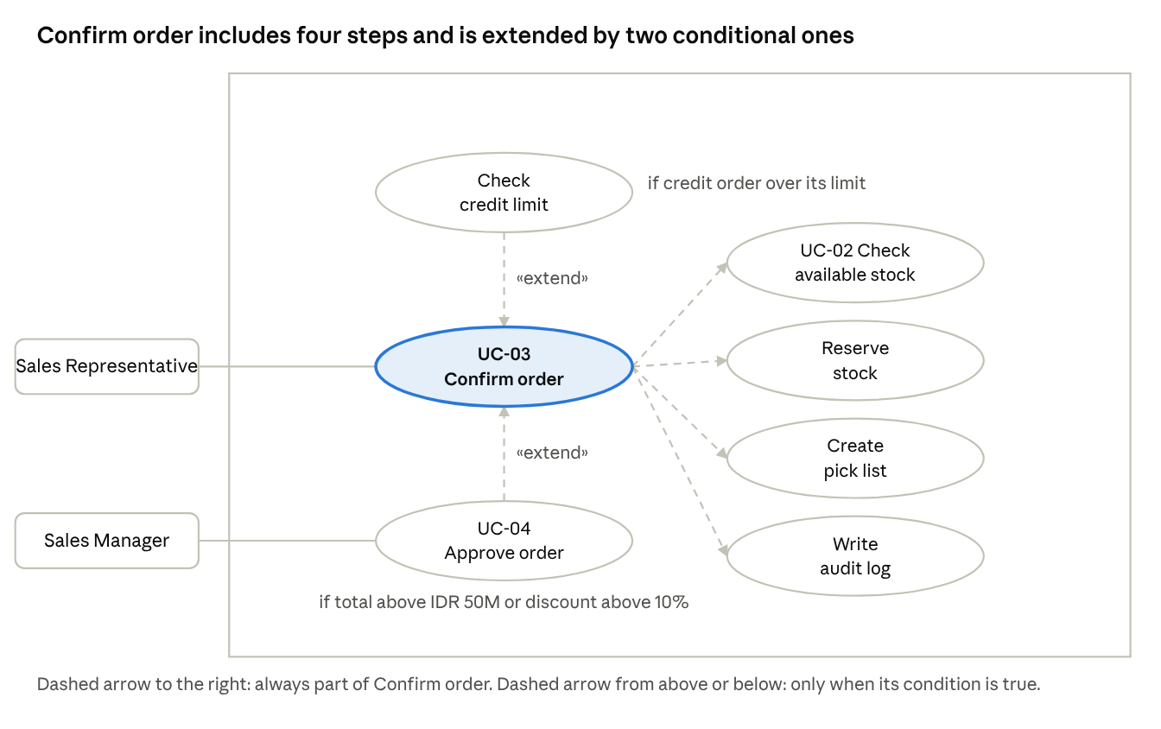
detailed use case · Confirm order with include and extend

A.2 User Flow: From Login to a Confirmed Order
This is the path a Sales Representative follows on the screens SCR-01 and SCR-04. If the quantity is not available the user changes it and tries again; if approval is needed the order waits for the Sales Manager.
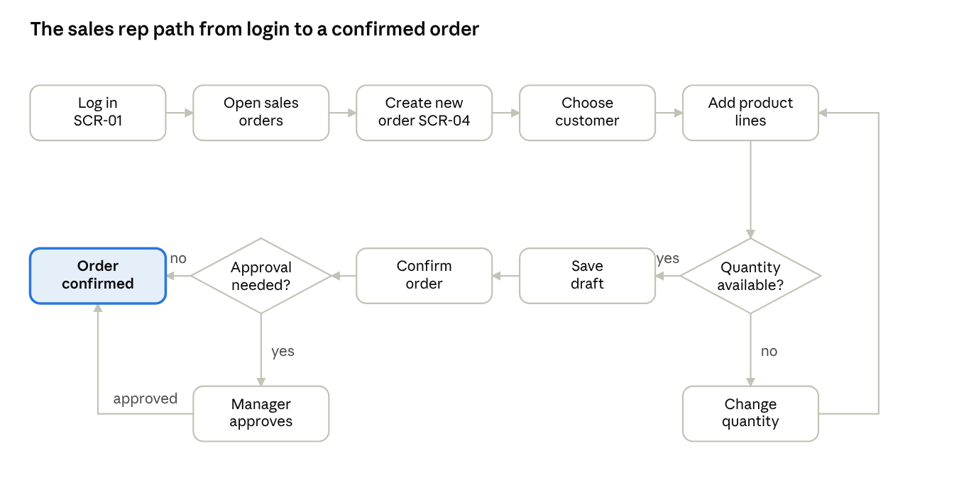
user flow · login to confirmed order

A.3 Activity Diagram: Order Confirmation Checks
The checks run in this order. Messages VAL-01 and VAL-02 are defined in section 12.
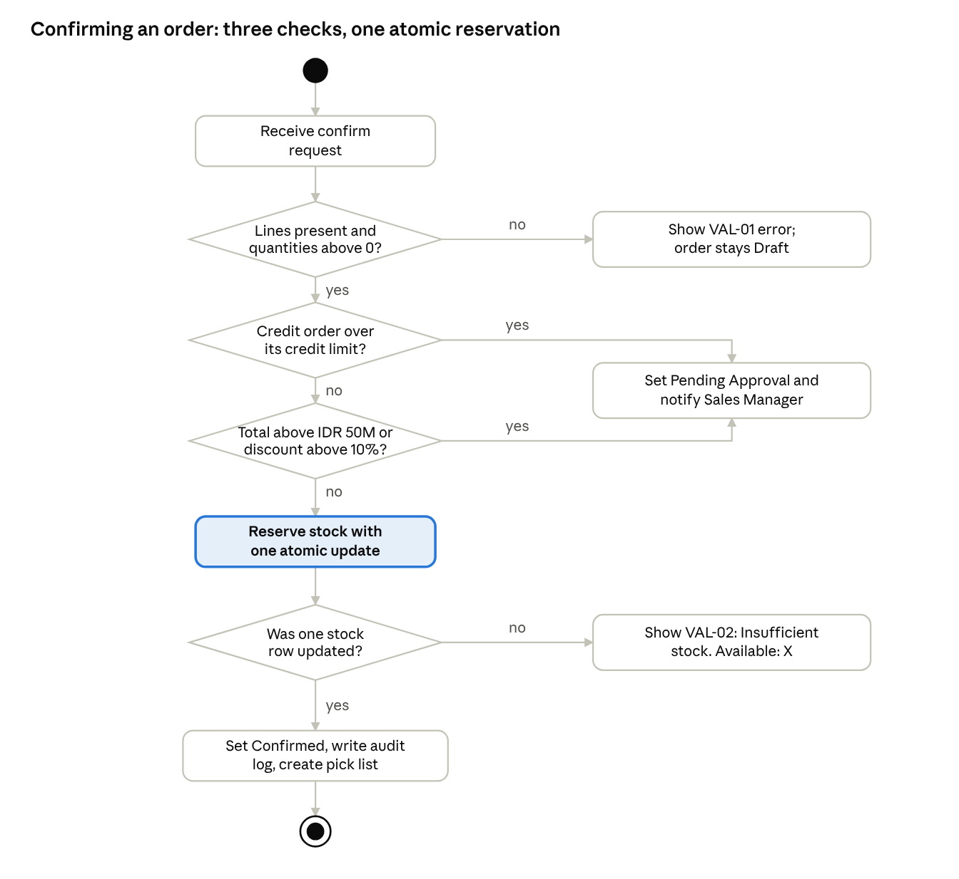
activity diagram · order confirmation checks

A.4 Component Diagram
The components below are the standard Odoo modules plus the custom rules and shared services this project adds. Arrows show which component calls which.
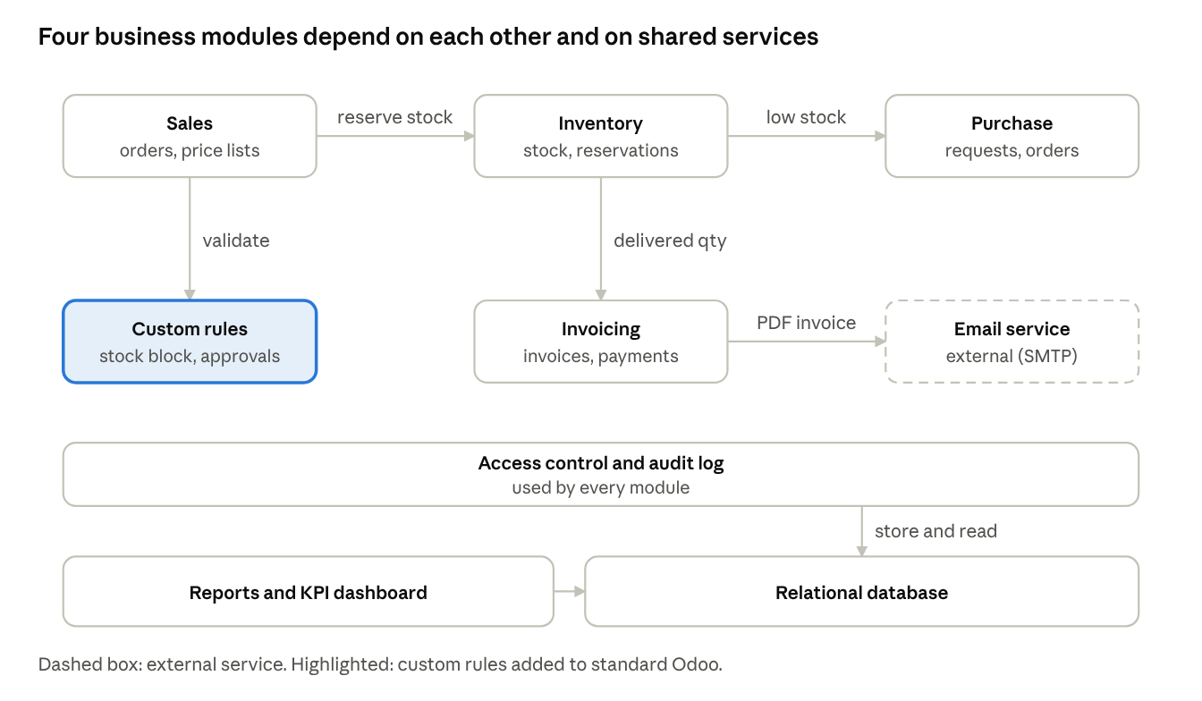
component diagram · modules and shared services

A.5 Class Diagram (Core Domain)
The classes correspond to the main tables in the data model. Attribute lists are shortened to the fields that matter for the behaviour described in this document. Multiplicity: 1 means one, * means many.
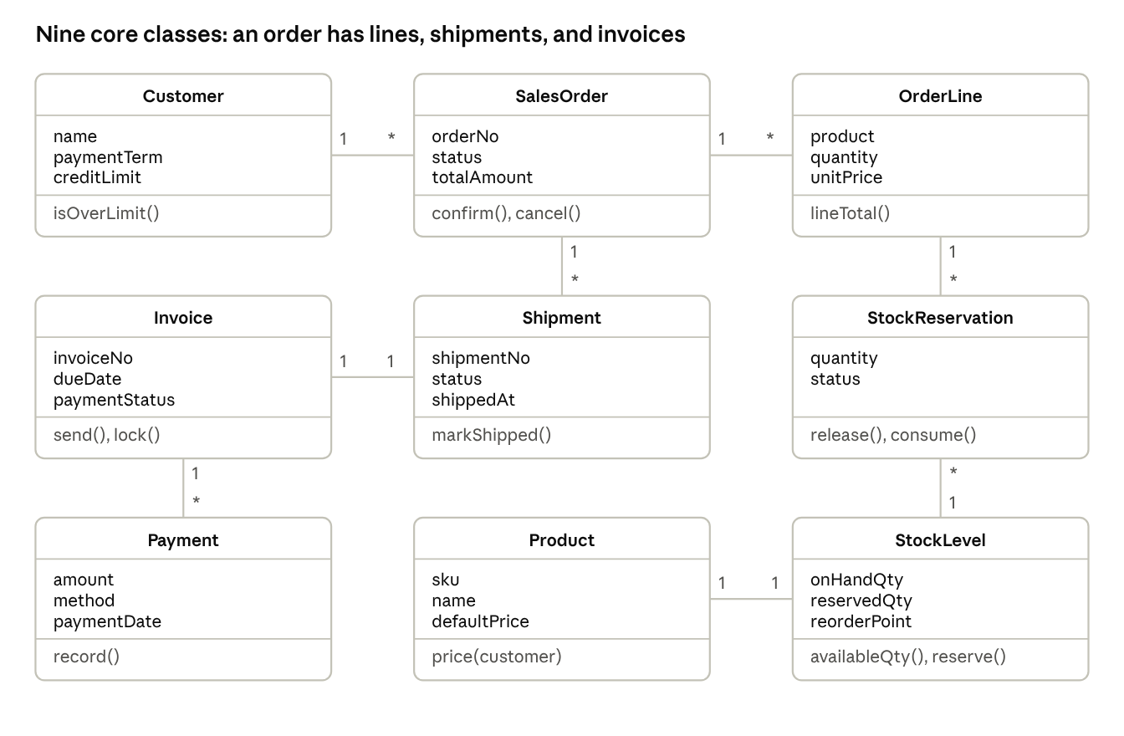
class diagram · nine core classes

A.6 Integration Flowchart: Invoice Email
The only external integration in phase 1 is the outgoing email service. There is no payment gateway and no WhatsApp integration. The retry limit is an open decision (see OI-05 and the email configuration).
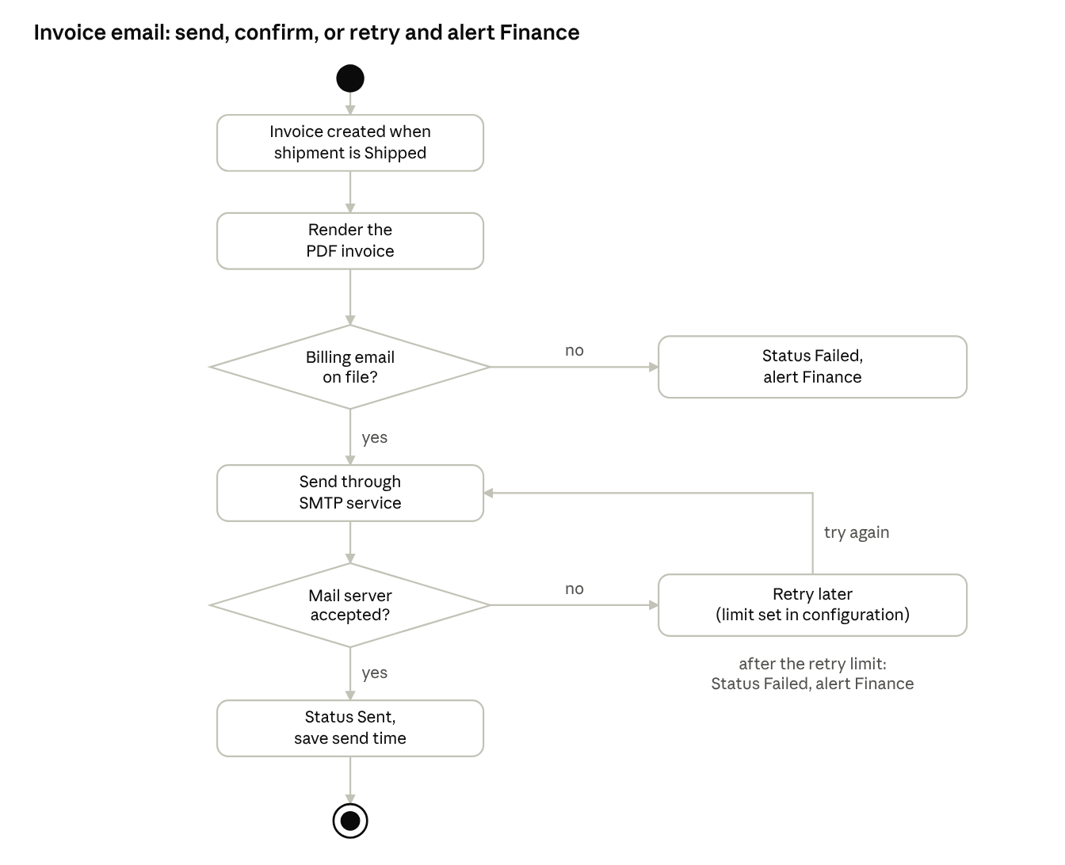
integration flowchart · invoice email through SMTP

